|  |  |
| --- | --- |
| **Exp No: 4**  **Date: 30.3.25** | **PERSONAL INFORMATION** |

**AIM:**

To create a web form that accepts a user’s name and age and to write a servlet to process the form data and display it back on the browser

**PROGRAM:**

**User.html**

<!DOCTYPE html>  
<html>  
<head>  
<meta charset="ISO-8859-1">  
<title>Insert title here</title>  
</head>  
<body>  
<p>USER DETAILS</p>  
<form method="GET" action="/sachin-144/DisplayUser">  
<p>  
<label>Username:</label>  
<input type="text" name="Username" required>  
</p>  
<p>  
<label>Age:</label>  
<input type="number" name="Age" required>  
</p>  
<p>                                              
<input type="submit" value="Accept"/>      
</p>  
</form>  
</body >  
</html>

**User_validate.jsp**

package com.sachin.servlet;  
  
import java.io.IOException;  
import java.io.PrintWriter;  
  
import javax.servlet.ServletException;  
import javax.servlet.annotation.WebServlet;  
import javax.servlet.http.HttpServlet;  
import javax.servlet.http.HttpServletRequest;  
import javax.servlet.http.HttpServletResponse;  
  
/**  
 * Servlet implementation class DisplayUser  
 */  
@WebServlet("/DisplayUser")  
public class DisplayUser extends HttpServlet {  
private static final long serialVersionUID = 1L;  
         
    /**  
     * @see HttpServlet#HttpServlet()  
     */  
    public DisplayUser() {  
        super();  
        // TODO Auto-generated constructor stub  
    }  
  
/**  
* @see HttpServlet#doGet(HttpServletRequest request, HttpServletResponse response)  
*/  
protected void doGet(HttpServletRequest request, HttpServletResponse response) throws ServletException, IOException {  
   String a= request.getParameter("Username");  
String b = request.getParameter("Age");  
int c=Integer.parseInt(b);  
PrintWriter p =response.getWriter();  
if(!a.isEmpty() && c>0) {  
 p.println(a);  
 p.print(c);}  
else {  
p.println("login failed");  
}  
  
}  
  
/**  
* @see HttpServlet#doPost(HttpServletRequest request, HttpServletResponse response)  
*/  
protected void doPost(HttpServletRequest request, HttpServletResponse response) throws ServletException, IOException {  
// TODO Auto-generated method stub  
doGet(request, response);  
}  
  
}

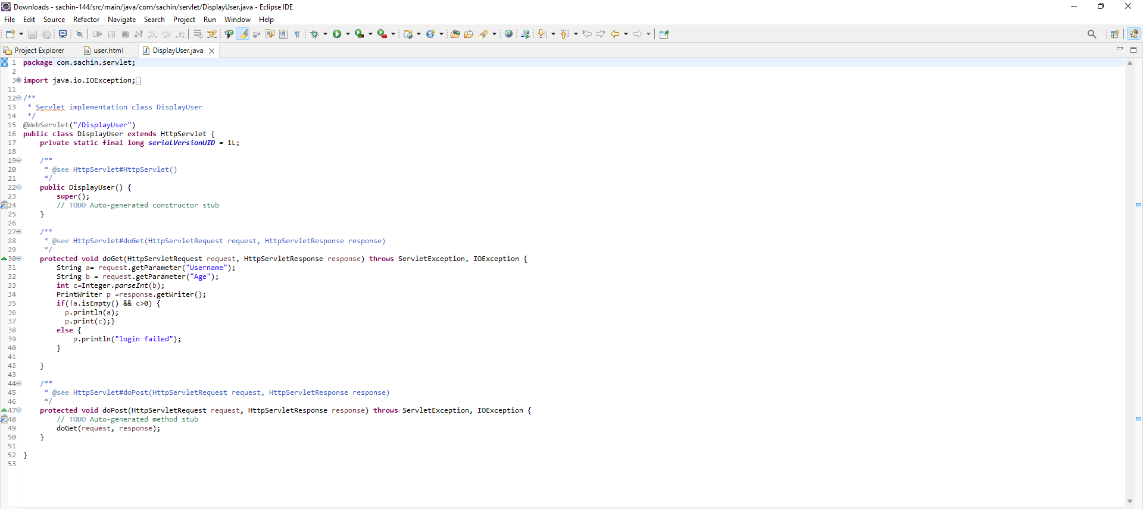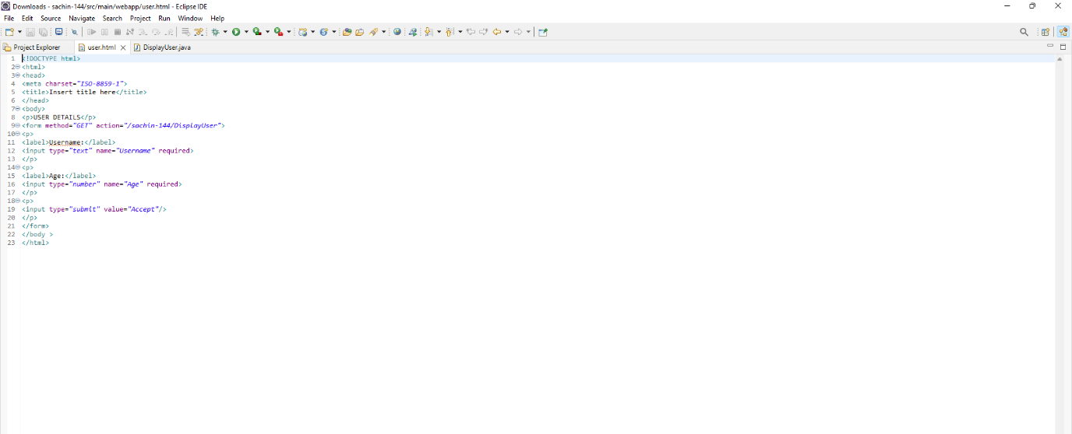

**OUTPUT:**

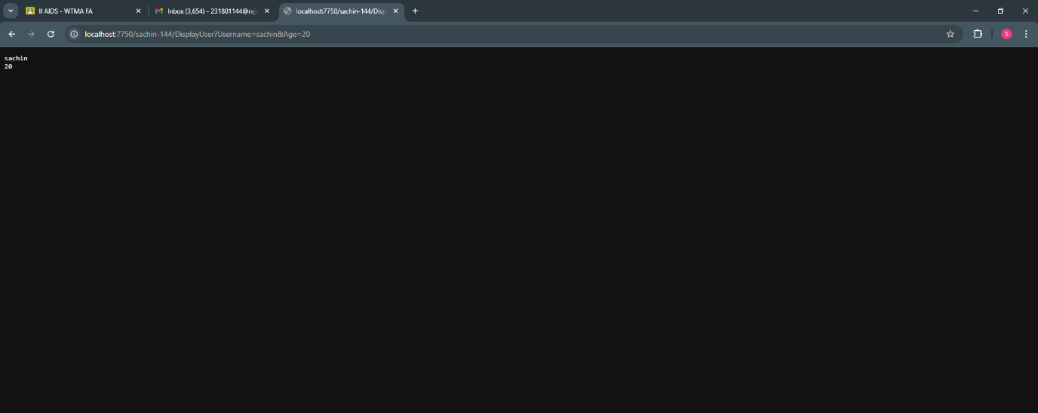

**RESULT :**Thus the create a web form that accepts a user’s name and age and to write a servlet to process the form data and display it back on the browser has been implemented and verify

successfully